# The Data Management System: User Manual

## Overview

The AMMRF Data Management System (DMS) allows researchers to:

* Ingest (store) data from configured instruments
* Manage their research data
* Advertise their research data through Research Data Australia (http://services.ands.org.au/home/orca/rda/)

This user manual describes how to use the DMS to manage research data.

This document covers the following Olympus microscopes: Confocal (FV1000), Live-Cell (Cell^R) and Total Internal Reflection Fluorescence (TIRF).

### System Requirements

The DMS is a web-based application so a web browser must be installed in order to access this. The supported browsers are as follows:

* Firefox 4 or greater
* Internet Explorer 8 or greater
* Safari 5 or greater

The download and upload of data uses a Java Applet so JRE (with browser plugin) must be installed on your computer. To check if JRE is installed and properly configured go to <http://www.java.com/en/download/testjava.jsp>.

If you are running Mac OS X and using Safari to access the DMS you should also change Java preferences. Go to Applications > Utilities > Java Preferences and select "Run applets in their own process"



## DMS Usage Instructions

## Login

To access the DMS go to <https://idms.acmm.sydney.edu.au/dms-web/> in your web browser.

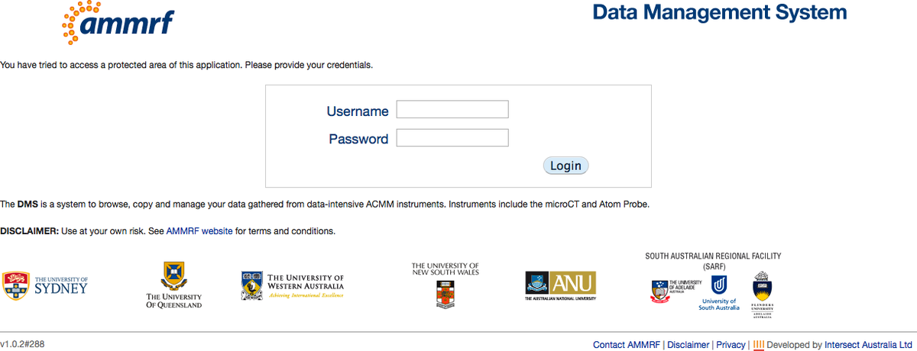

## Home Page

After login you will be redirected to the Home page which describes a high level description of the DMS workflow.

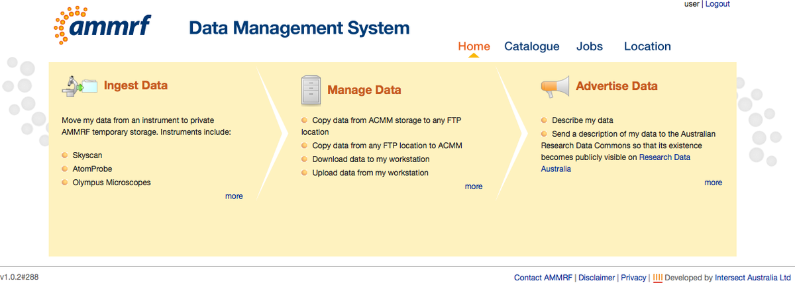

More detailed information about each step can be found by clicking on the “more” link.

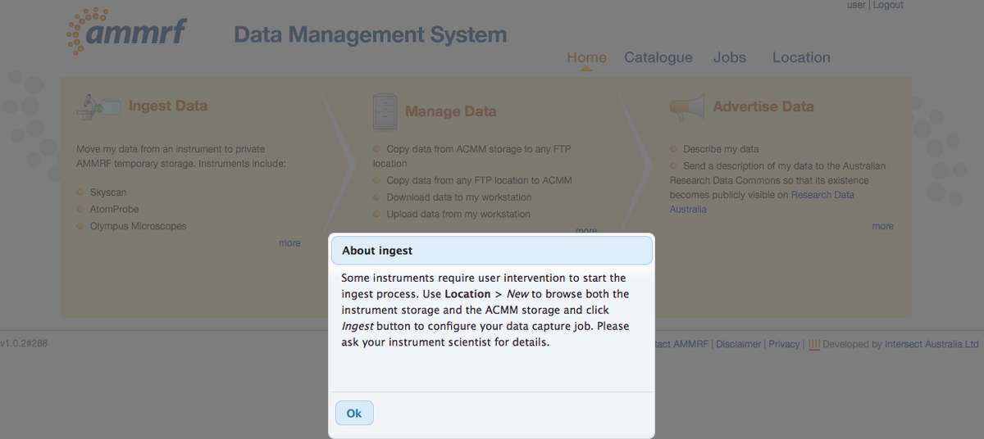

## Ingestion

Ingestion is the first step to storing experiment data in the DMS.

### Ingestion of datasets from the Olympus FV1000 Confocal microscope

Ingestion from the FV1000 microscope occurs automatically. Once the experiment has finished running, save your dataset under the Data_FV1000 root folder in your folder on the FTP ACMM server (“Y” mapped network drive). Your folder will be named as per your ACMM login name. Sub folders can be created as required.

To view your datasets in the DMS you should login as described in the Login section 1, and go to “Location” in the top menu.

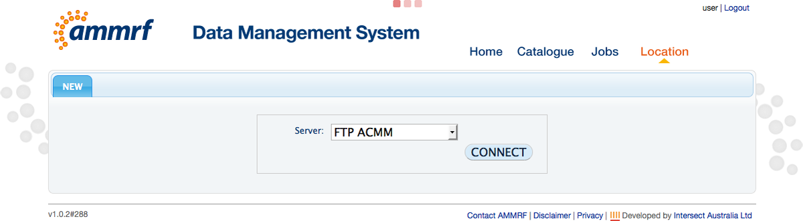

Select the “FTP ACMM” server and click the “CONNECT” button. A new tab with file tree will be opened. Navigate to your dataset by clicking on “+” beside the folders.

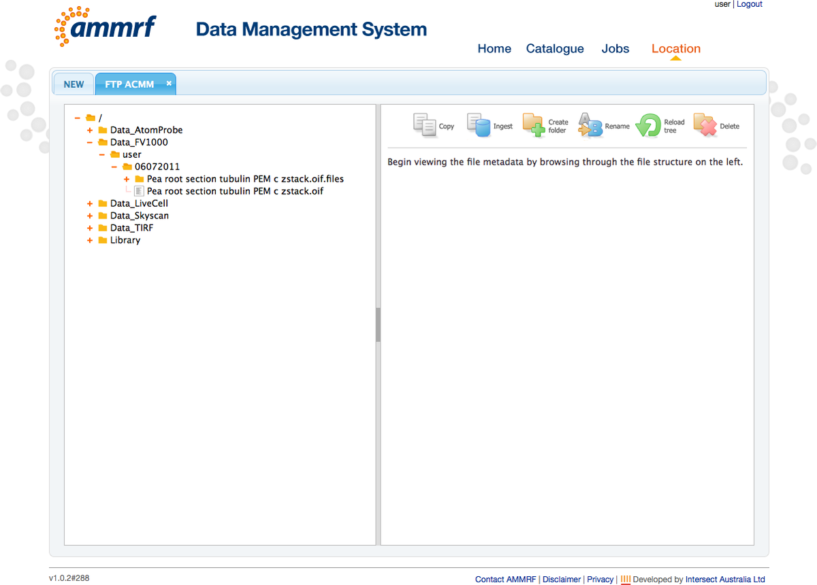

Automatic ingestion of the data will occur at a time configured by the DMS administrator. During this process, metadata (FV1000 instrument settings and the project description from the booking system) will be extracted from the experiment data set. Once this is complete, the metadata can be viewed by clicking on the *.oif file.

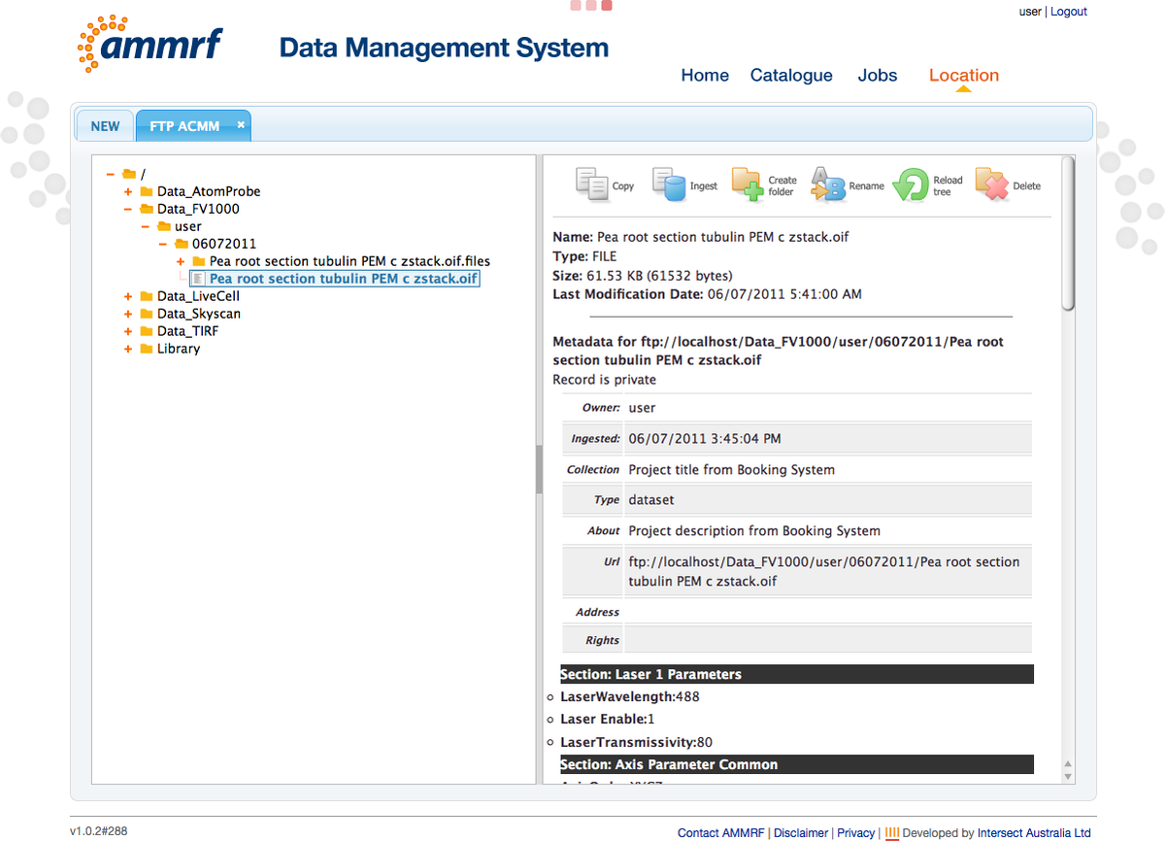

By navigating to the “Jobs” module, you will be able to see your ingestion job in your job list.

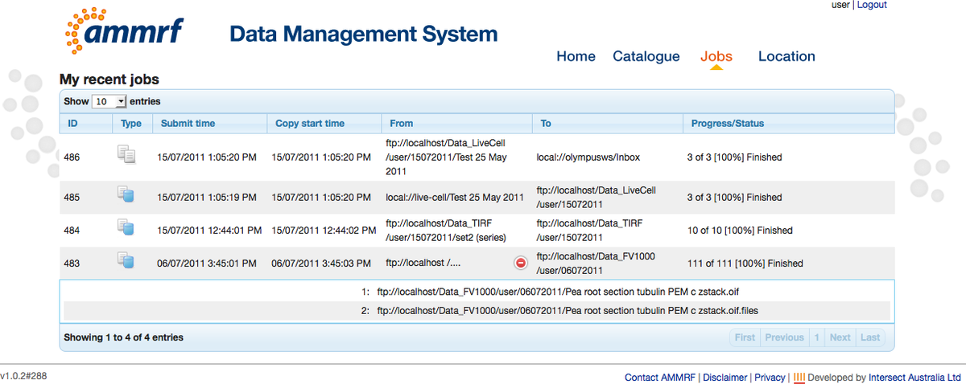

By navigating to the “Catalogue” module, you will be able to see your ingested dataset.

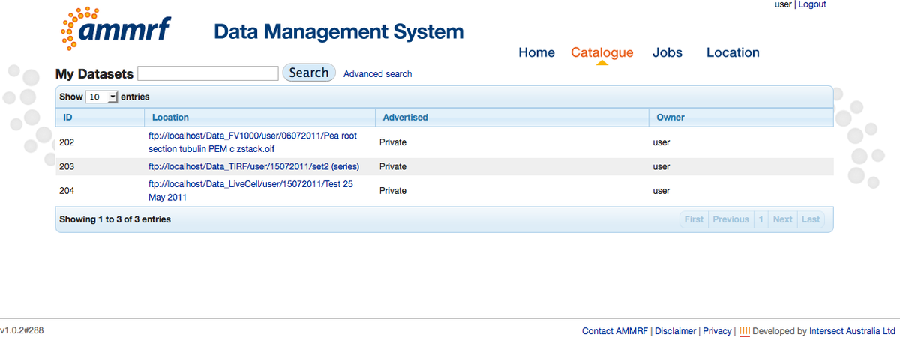

Click on the link in the table to see the metadata.

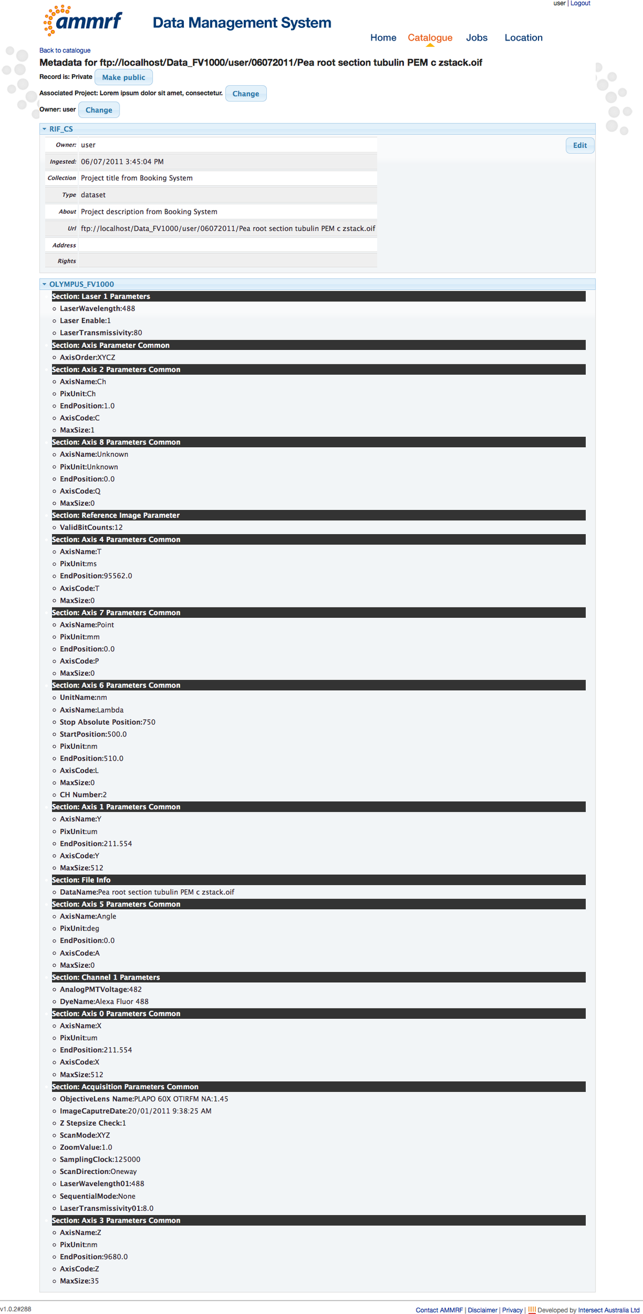

### 3.2 Ingestion of datasets from the Olympus TIRF microscope

Data Ingestion from the TIRF microscope occurs automatically. The workflow is the same as for ingestion of datasets from the FV1000 microscope (as described in section 3.1).

Data should be saved under the Data_TIRF root folder. Data sets should also be saved in separate folders.

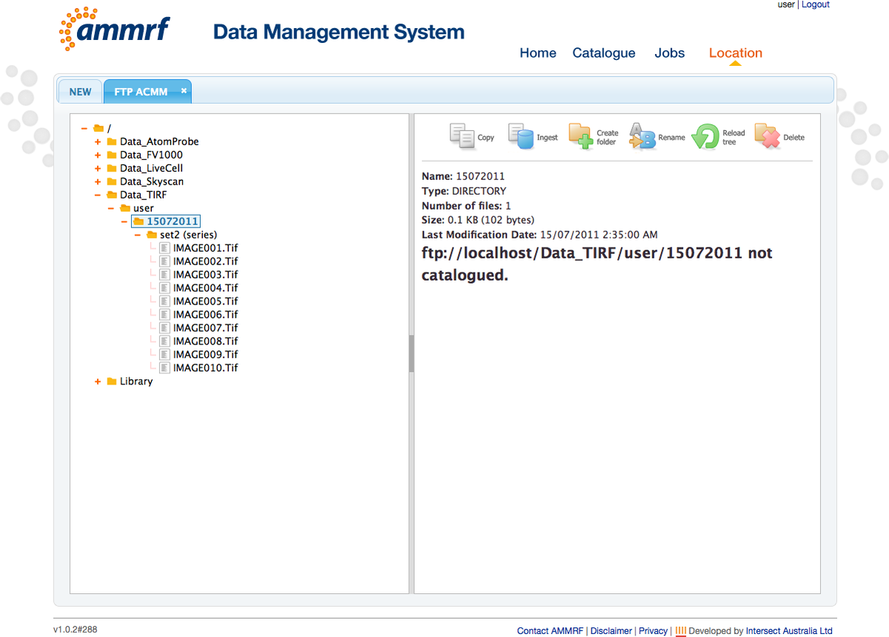

Extracted metadata can be viewed by clicking on the data set folder.

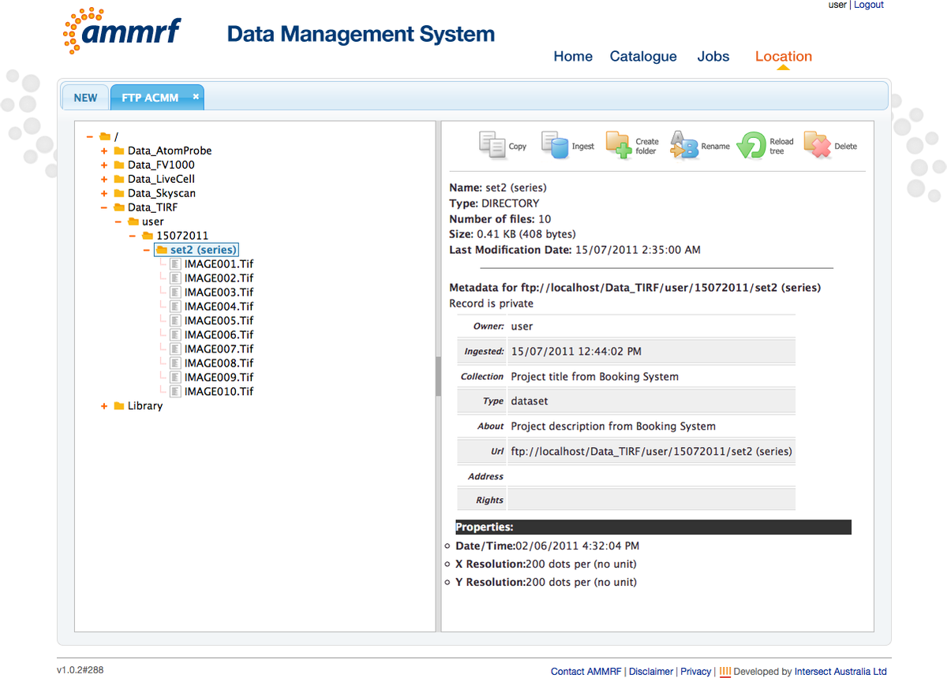

The description of “Jobs” and “Catalogue” from the FV1000 instructions applies to TIRF datasets also.

### Ingestion of datasets from the Olympus Live Cell (Cell^R) microscope

Data Ingestion from the Cell^R microscope is manual. Data should be saved to the local drive first. When data is ready for ingestion, login to the DMS and go to the “Location” module as described in previous sections.

Connect to the “FTP ACMM” server and the “Olympus CellR” instrument.

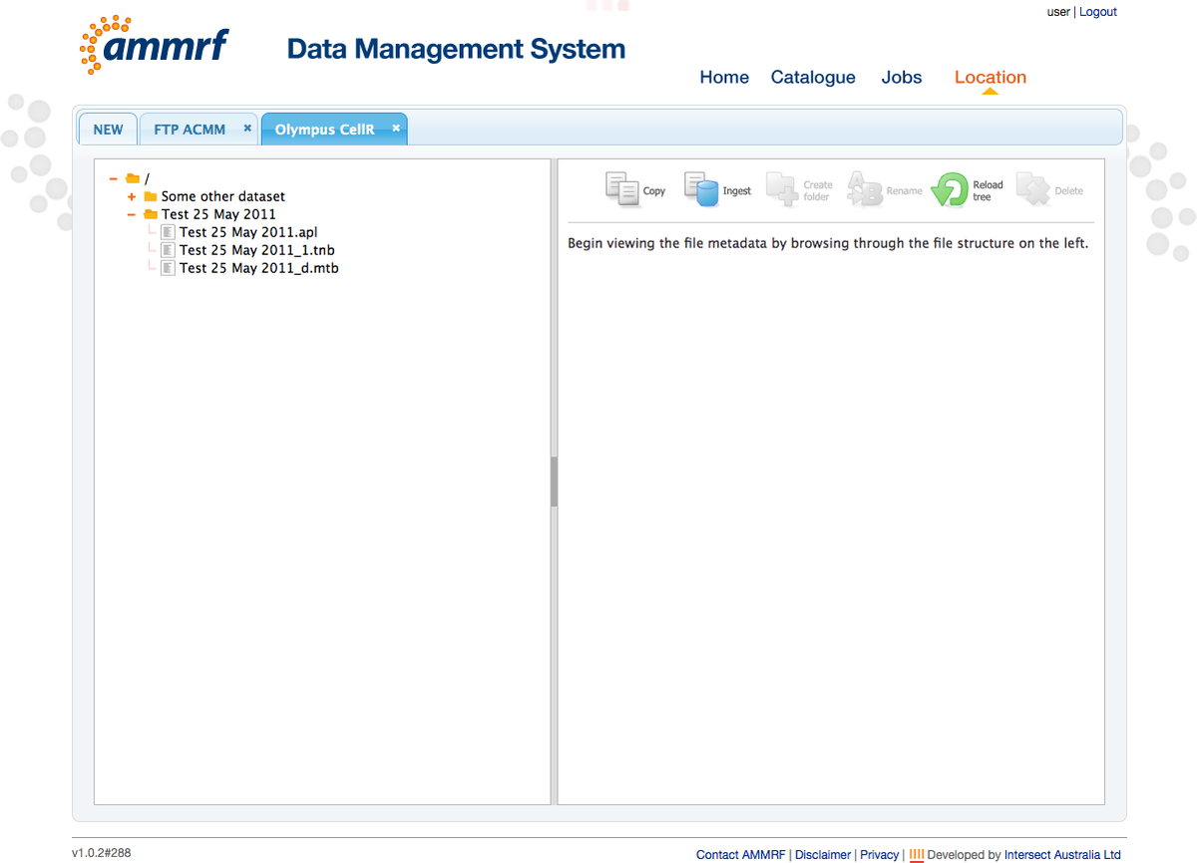

Click the “Ingest” icon and select From: Olympus CellR, To: FTP ACMM in the ingestion popup wizard.

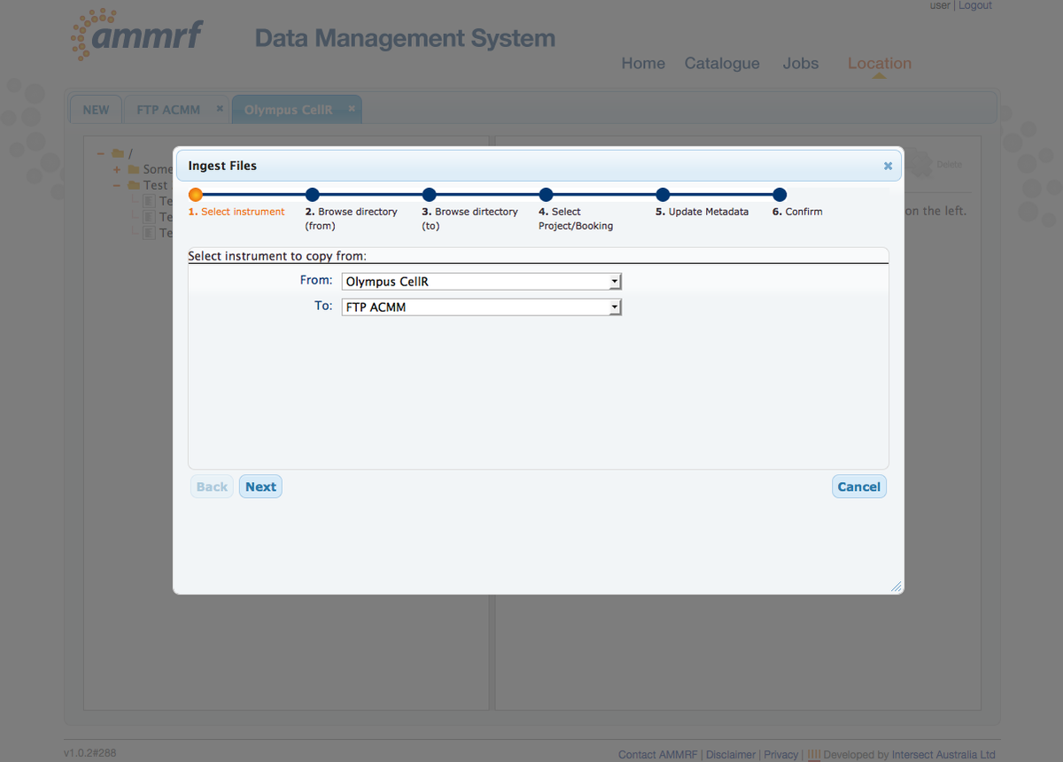

Click “Next” and select the dataset you want to ingest.

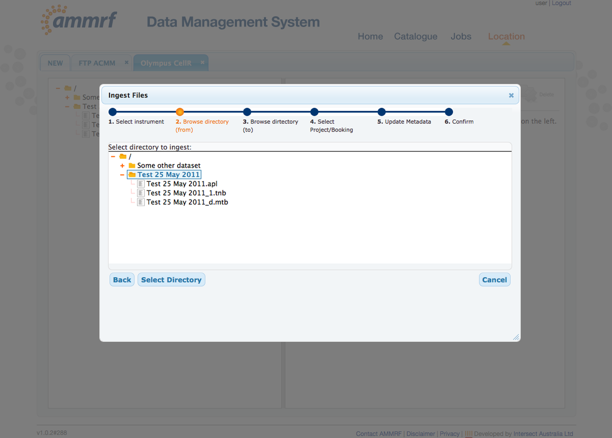

Click “Select Directory” and select the destination folder on the FTP server. You can also check the “Copy to Workstation” checkbox to have your dataset copied to the Cell^R workstation into the “Inbox” folder.

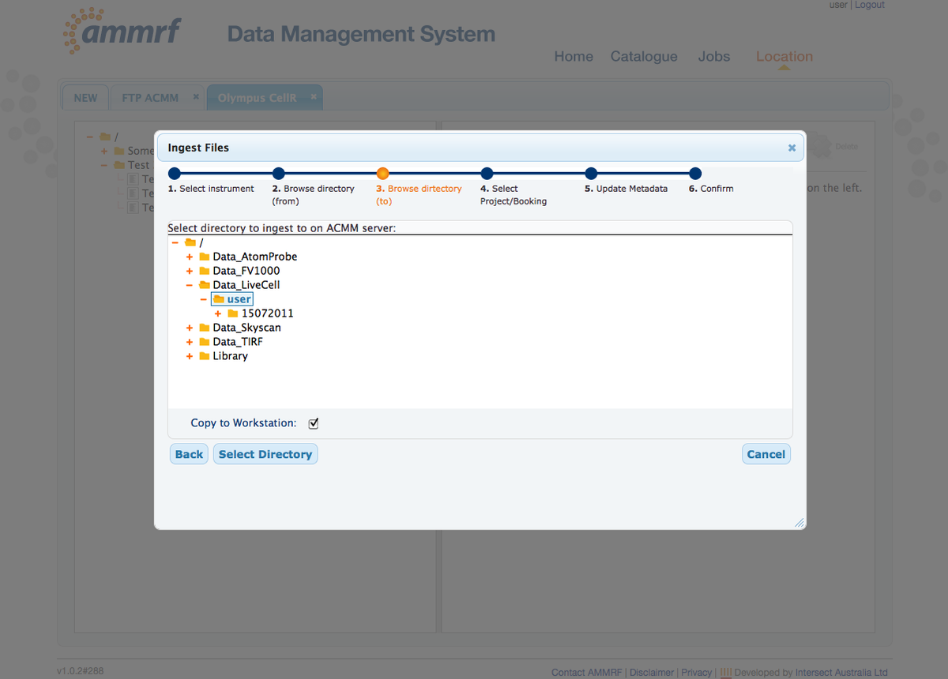

It is possible to create a destination folder on the FTP server before clicking on the “Ingest” icon. See the following section “Create/Delete/Rename” for details.

Click “Select Directory” and select the Project and Booking ID (from Booking System) which you used to create this dataset. To list your projects and bookings select booking date range in “From Date” and “To Date”.

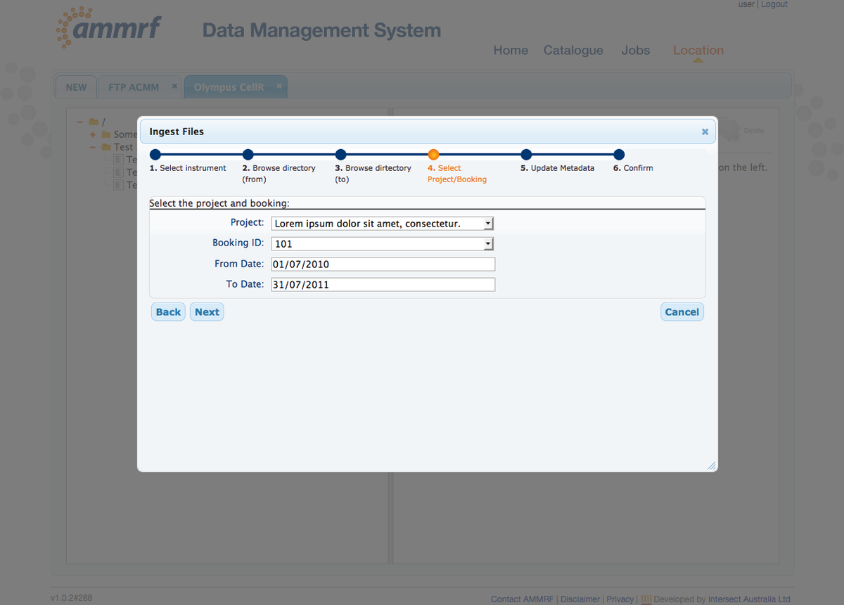

This will pre-populate your personal metadata with information held within the Booking System.

Click “Next”. This pre-populated metadata can be edited here.

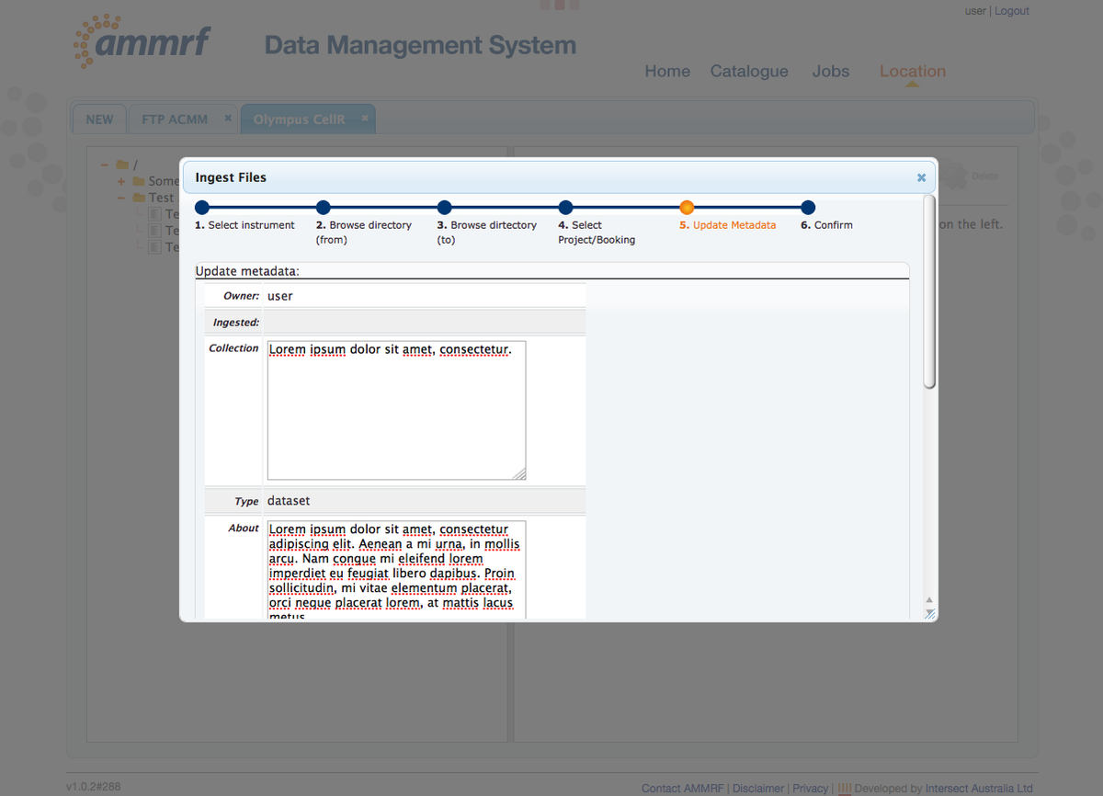

Click “Next” when metadata editing is complete. At this final step you can confirm all previous steps. Click “Confirm” to start ingestion.

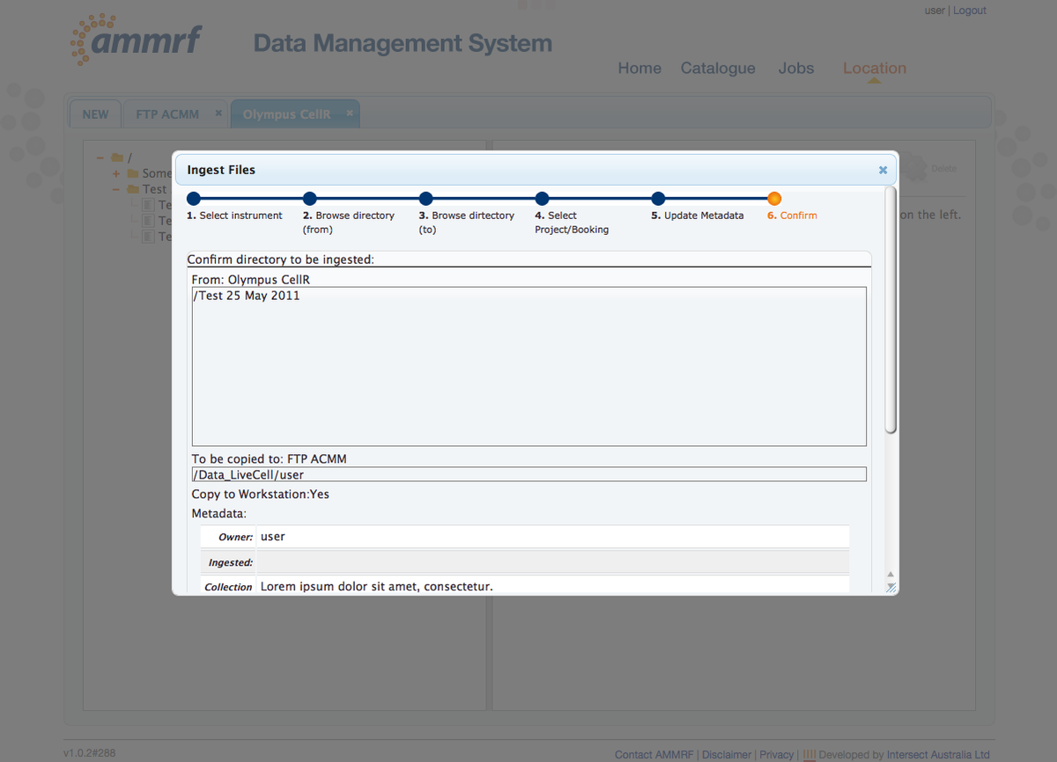

The Ingestion job will be created. Once this has been completed, extracted metadata can be viewed when clicking on the dataset folder.

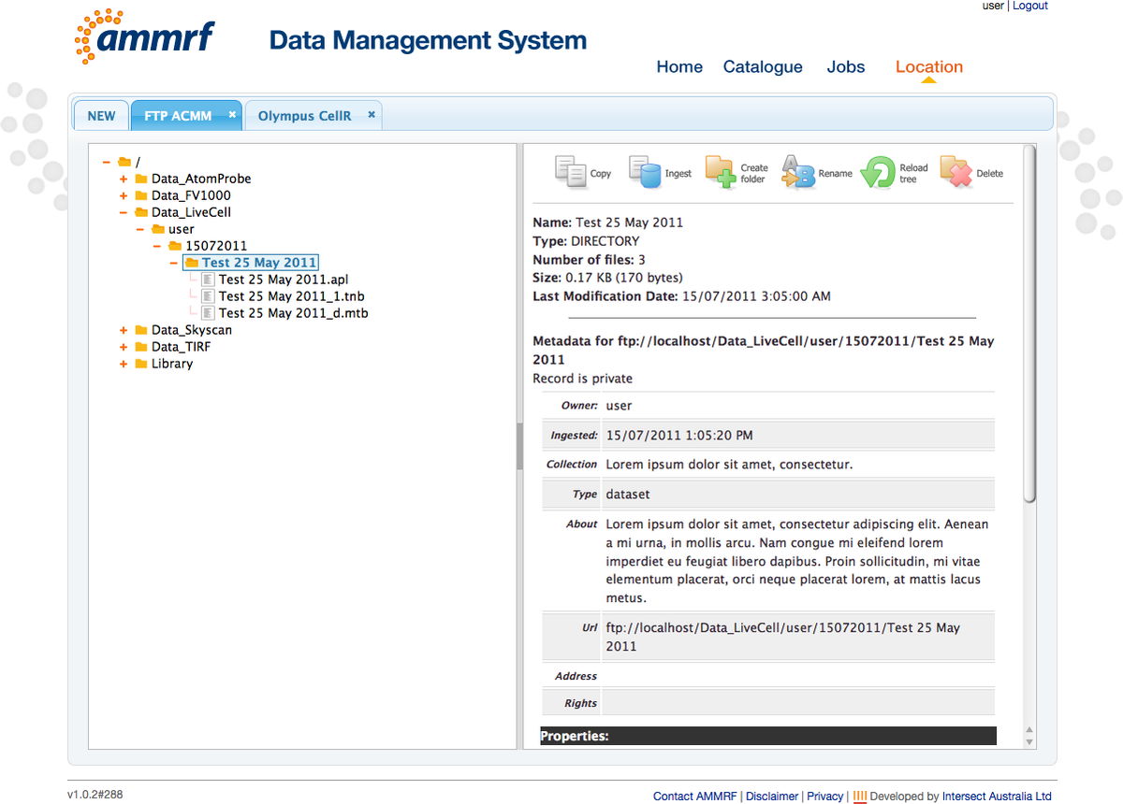

You can check the job progress in the “Jobs” module and find your datasets in the “Catalogue” module. The description of “Jobs” and “Catalogue” from sections 3.1 and 3.2 applies to Cell^R datasets also.

If you checked the “Copy to Workstation” option in the ingestion wizard, a “Copy” job will be viewable in the jobs table.

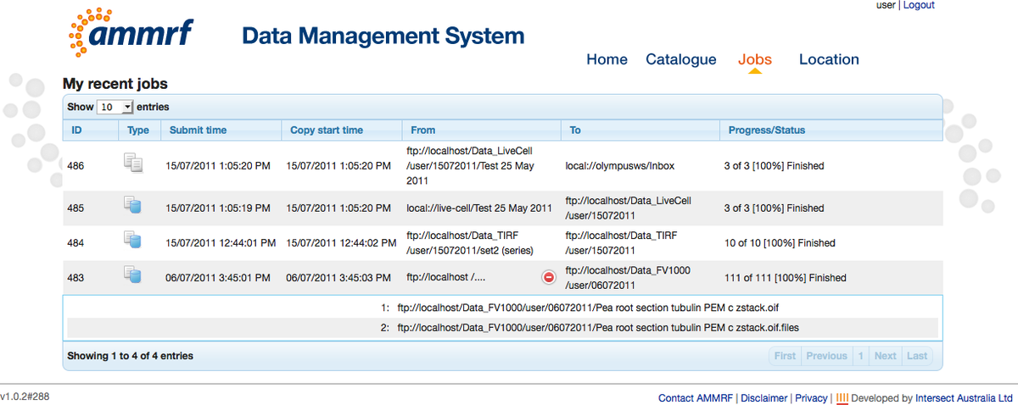

You will also find your dataset in the “Inbox” folder of the Cell^R workstation.

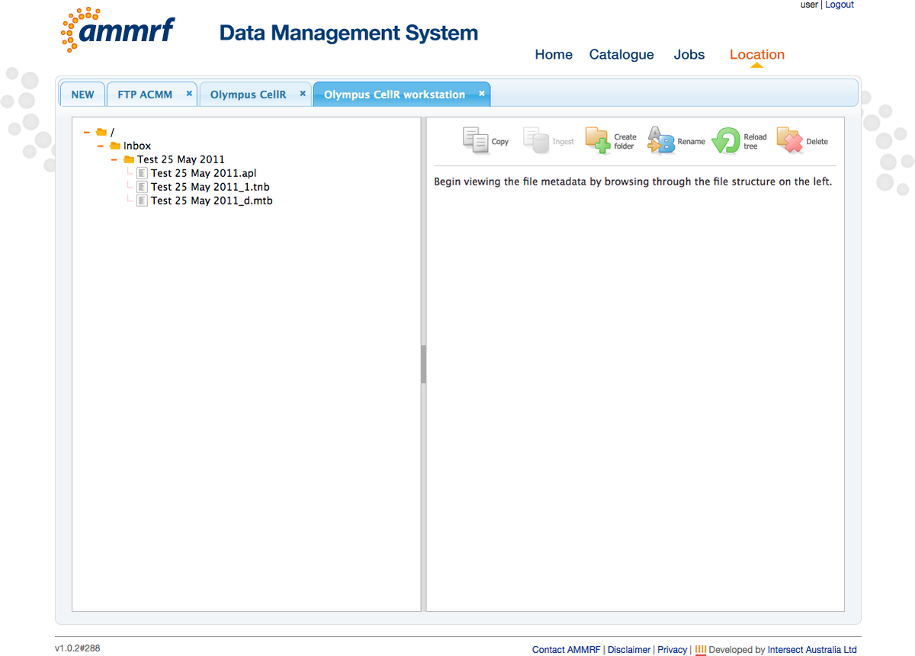

## Data management

The DMS allows you to manage your research data. It provides the following interfaces:

* Copy data across a configured set of servers/computers
* Download/Upload data
* Create/Delete/Rename folders to organize your data
* Search your datasets in the Catalogue
* Edit the metadata record for your datasets
* Advertise your research data in Research Data Australia

### Catalogue Search

To search for your data go to the “Catalogue” module. By default, all your data will be shown in the table.



The DMS has “Basic” and “Advanced” searches.

The “Basic” search performs full text search across text metadata fields. To basic search type search terms in the Search input box and click the “Search” button. You can use wildcard characters like ‘*’ and ‘?’. The datasets table will be updated with the search results.

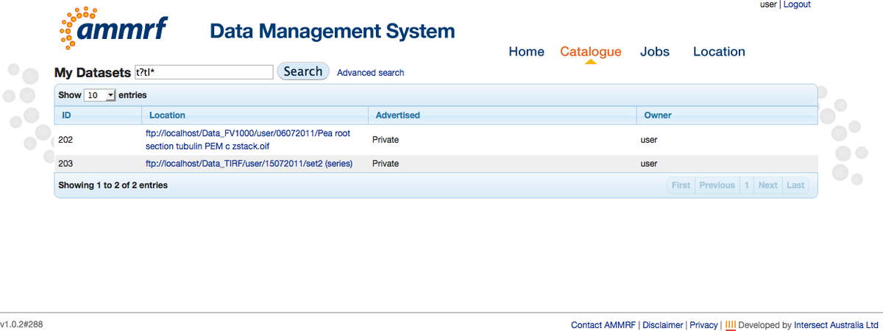

Click on the link in the table to see the metadata.

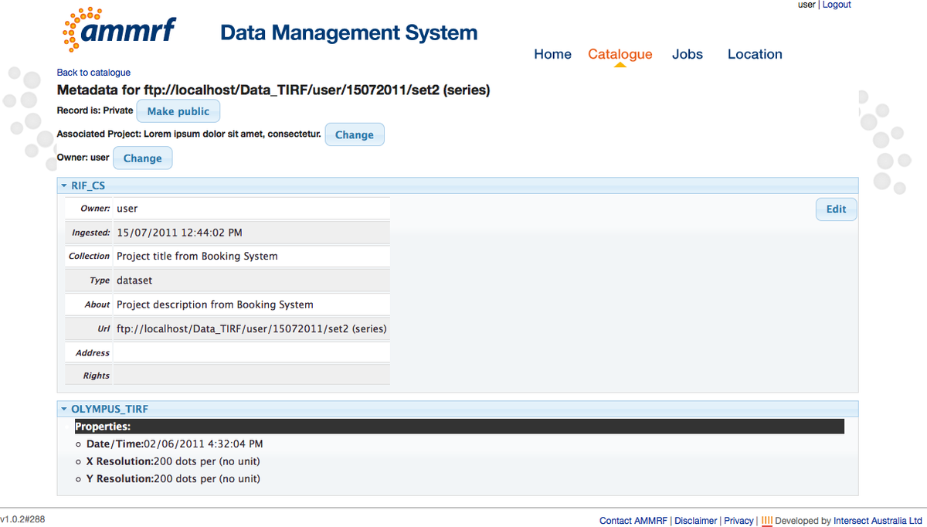

The “Advanced” search allows you to perform more precise searches. Click on the “Advanced search” link (next to the Search button) to access this.

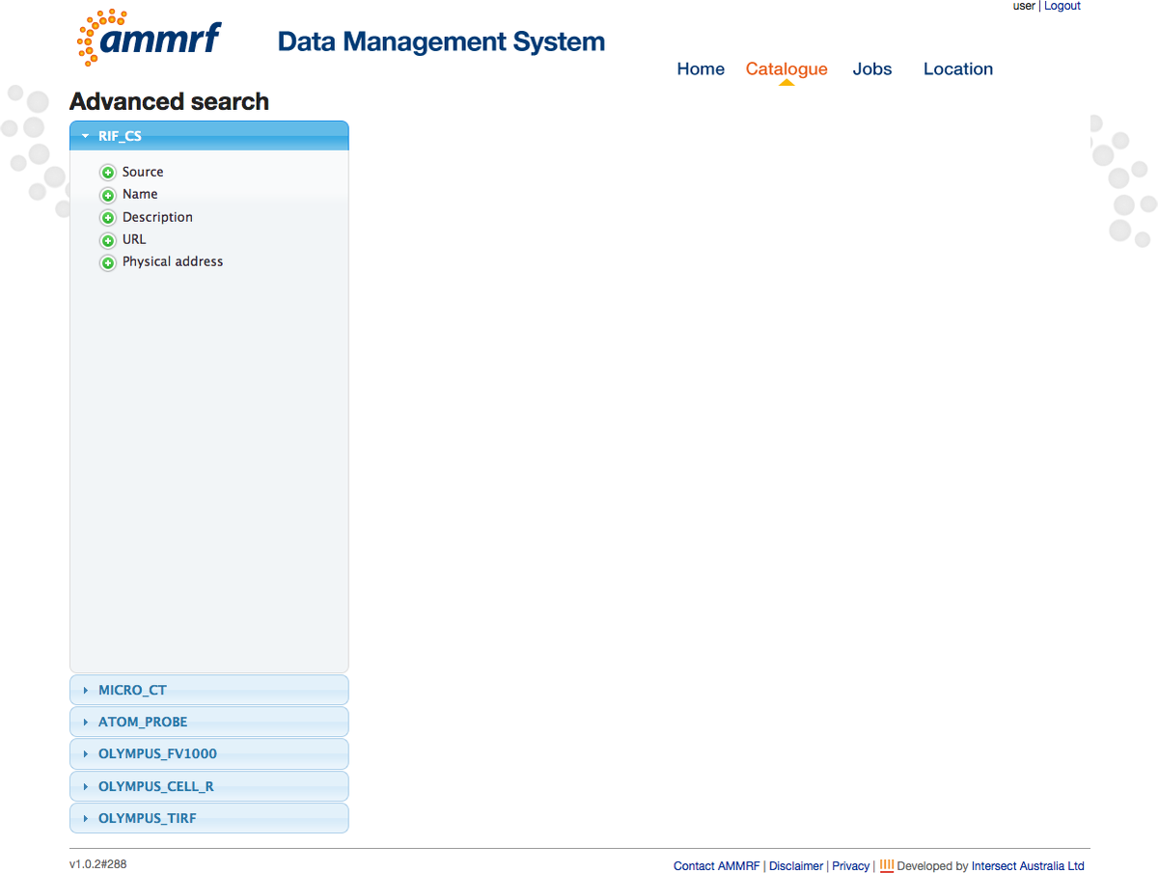

Metadata fields to be searched can be selected from the left hand side accordion. Click on the green plus icon next to the field name to add it to the search – a corresponding input field will be added. Type a search value to this new input field. Based on the metadata field type, the corresponding input field will be created (text input, number input, date picker). Several fields may be selected from any of the schemas listed in the accordion. If selected several fields are selected this will perform an implicit “AND” search. You can remove fields from the search by clicking on the red minus icon next to the input field. Once a query has been built, click the “Search” button to get results.

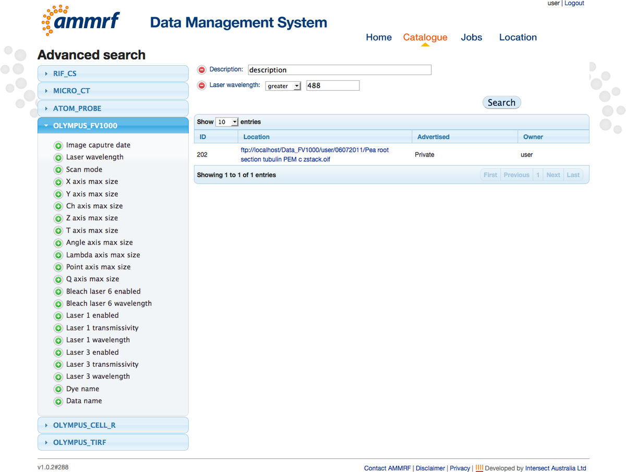

### Metadata edit

You can edit the metadata associated with each dataset. Find your dataset in the “Catalogue” module and open the metadata details. In the RIF-CS section click “Edit” button and edit metadata in the popup window. Click “Save” to save your modifications.

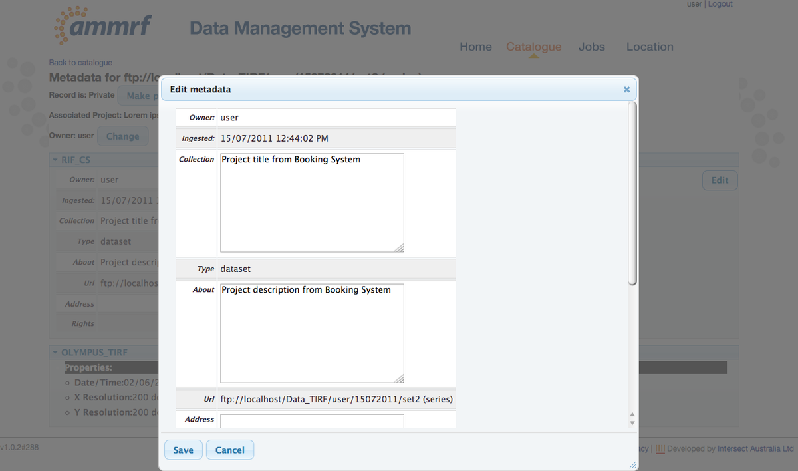

### Create/Delete/Rename folders

In the “Location” module you can Create/Delete/Rename folders on the servers and machines that are configured to allow this functionality.

Connect to the server/machine and in the list of actions (right hand side icons) you will see the allowed actions. If an action is not allowed then the corresponding icon will be greyed out and disabled.

To Create a folder select the file tree folder you want to create the folder in and click the “Create folder” icon. Type the new folder name in the popup window and click the “Create folder” button.

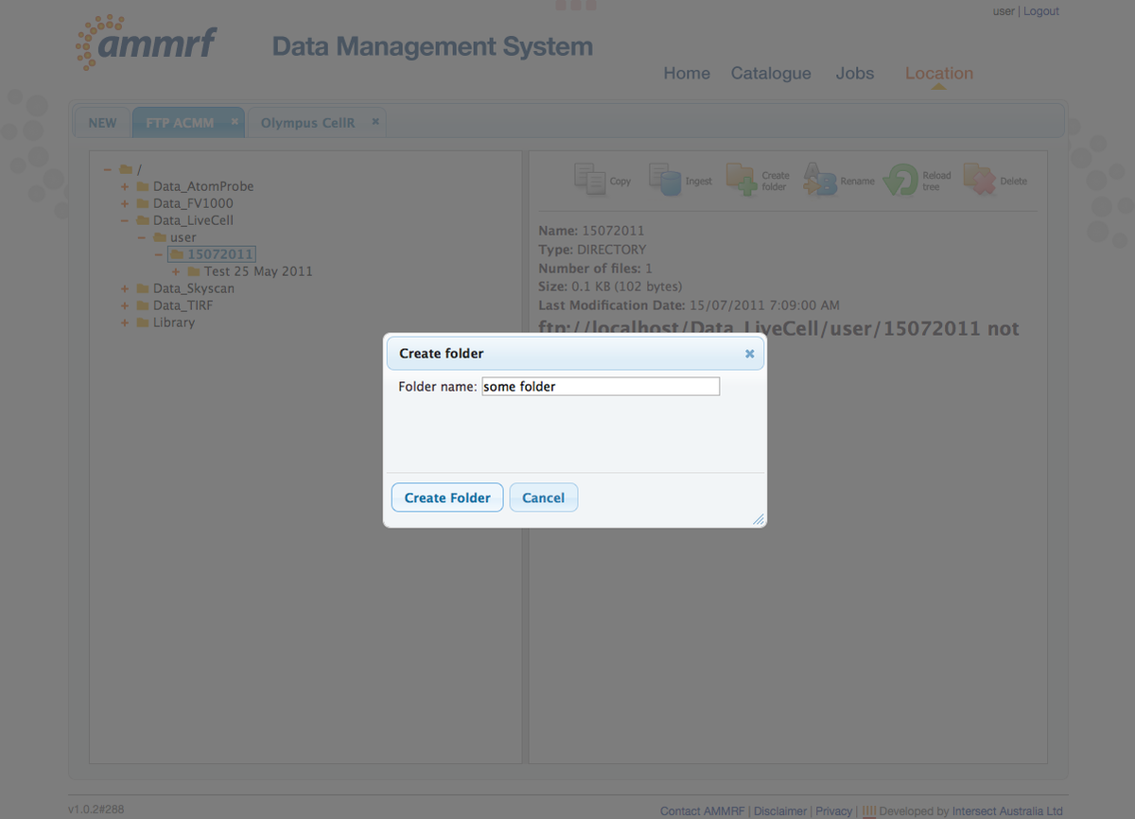

The tree list will be refreshed and a new folder will appear.

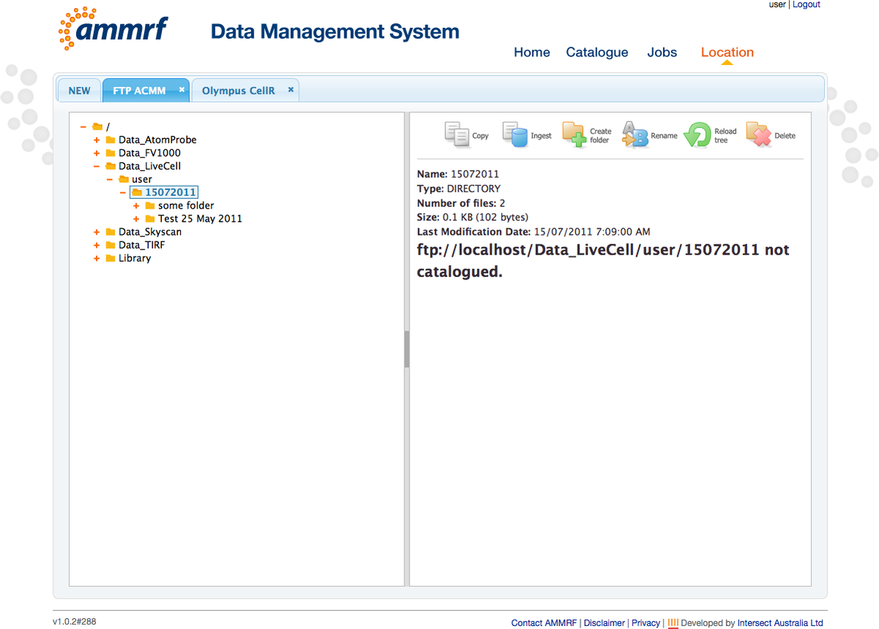

To Rename the folder/file select it in the tree and click the “Rename” icon. Type the new name in the popup window and click “Rename”.

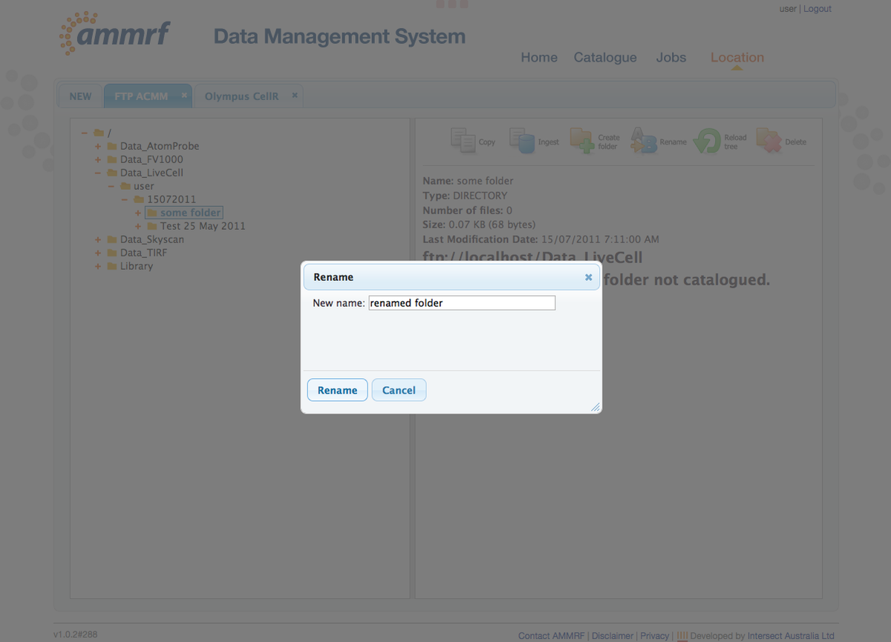

The tree list will be refreshed and you will see folder/file name changed.

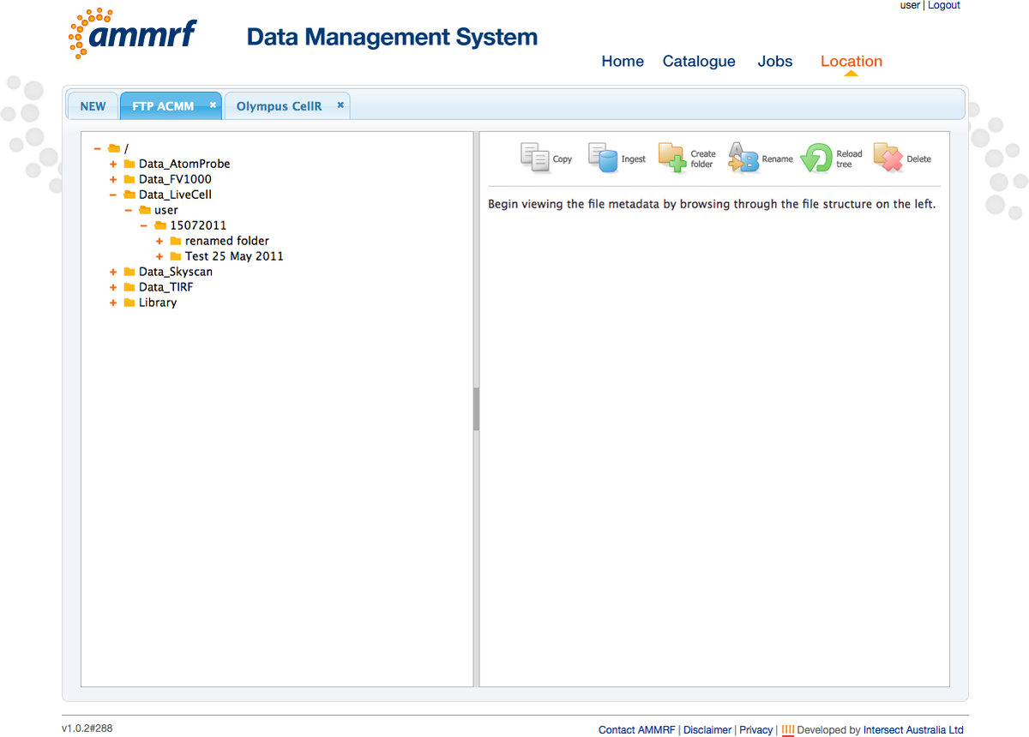

To Delete a folder/file select it in the tree and click the “Delete” icon. Click “Delete” in the confirmation popup.

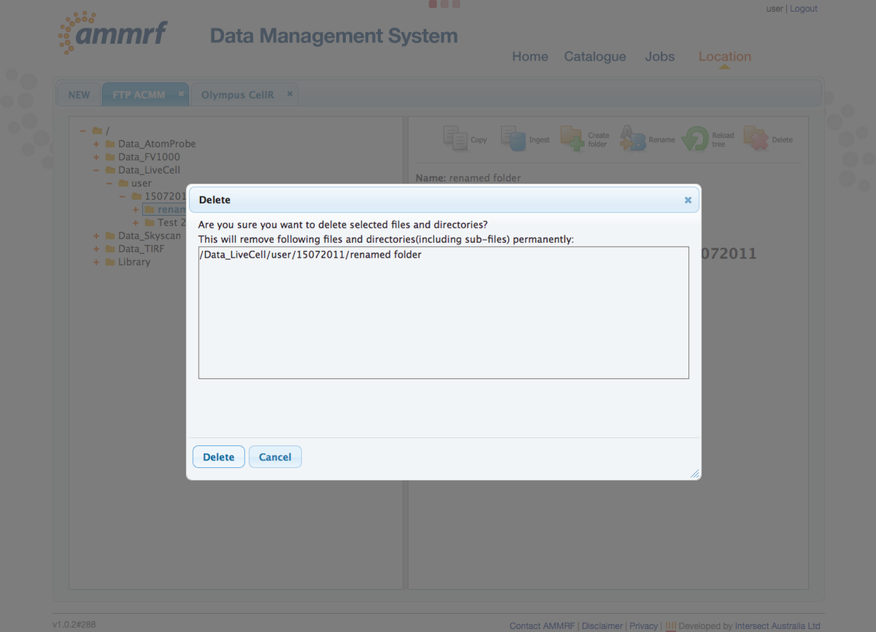

### Copy data

You can copy data across configured servers. Connect to source and destination servers in the “Location” module. Click the “Copy” icon to open the copy wizard.

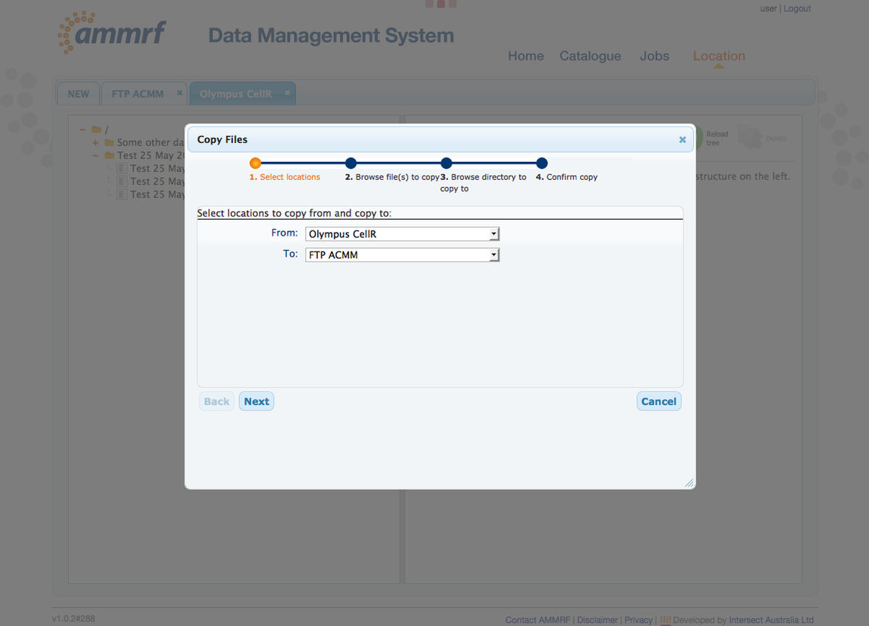

Follow the wizard steps: select source folders and files, destination folder and confirm on the last step. The Copy job will be created. You can track the job progress in the “Jobs” module.

### Download and Upload

NOTE: Download and upload uses a Java Applet so you should have JRE (with browser plugin) installed on your computer. To check if you have it installed and properly configured go to <http://www.java.com/en/download/testjava.jsp>

Download and Upload is performed the same way as copy from one server to another (see previous section for details). To download or upload just connect to “PC Up/Download” in the “Location” module. You will then be able to browse your hard drive.

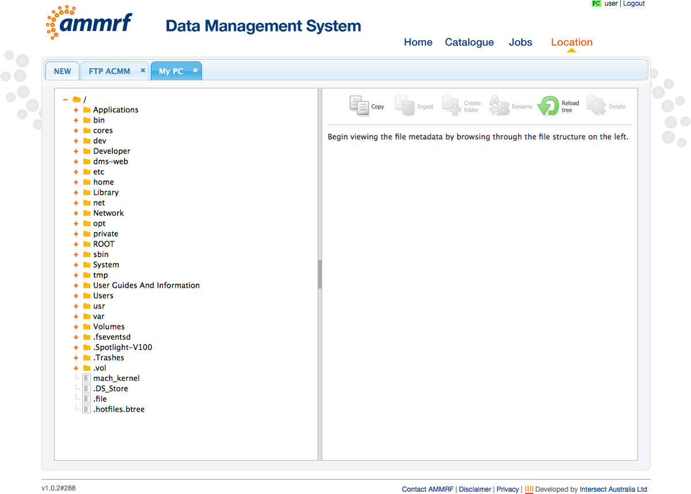

To perform a Download, click the “Copy” icon and select “My PC” as the destination server. To perform an Upload click the “Copy” icon and select “My PC” as the source server. Follow the copy wizard steps as usual (see previous section for details).

When you confirm on the last step of the copy wizard, a new popup window will open to perform the upload/download.

Do not close this window until the copy job finished. When the job has finished you should close this popup window or the next upload/download will fail.

## 3. Advertising

The AMMRF encourages researchers to advertise their research data metadata in Research Data Australia, so that its existence can be discovered by other researchers.

To make your dataset visible in Research Data Australia go to the “Catalogue” module. Find the dataset that you want to advertise. Go to metadata details. You will see that dataset is “Private”. Next to this information there is “Make public” button. Click on it and confirm in the popup window.

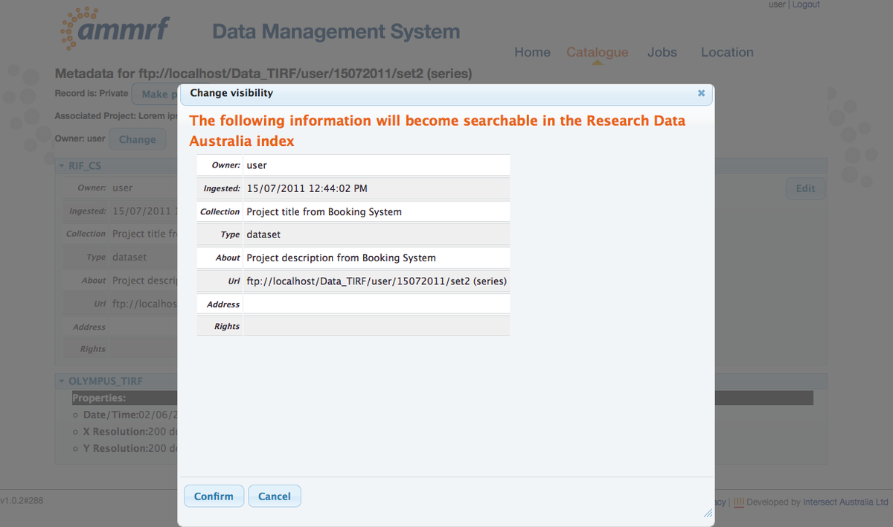

The Page will reload and dataset should have “Public” status.

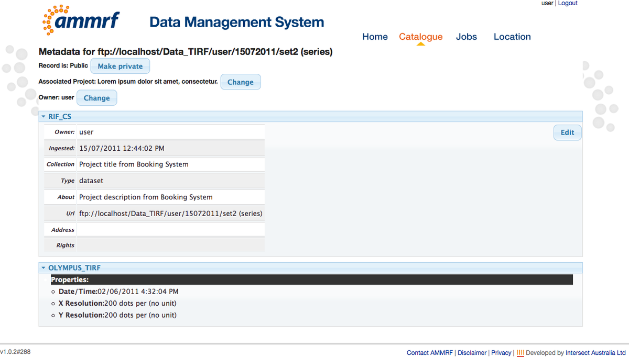

Your published dataset will eventually appear in Research Data Australia.